Personal My Profile My Profile

- My Profile - Pending Cancel Option required

2.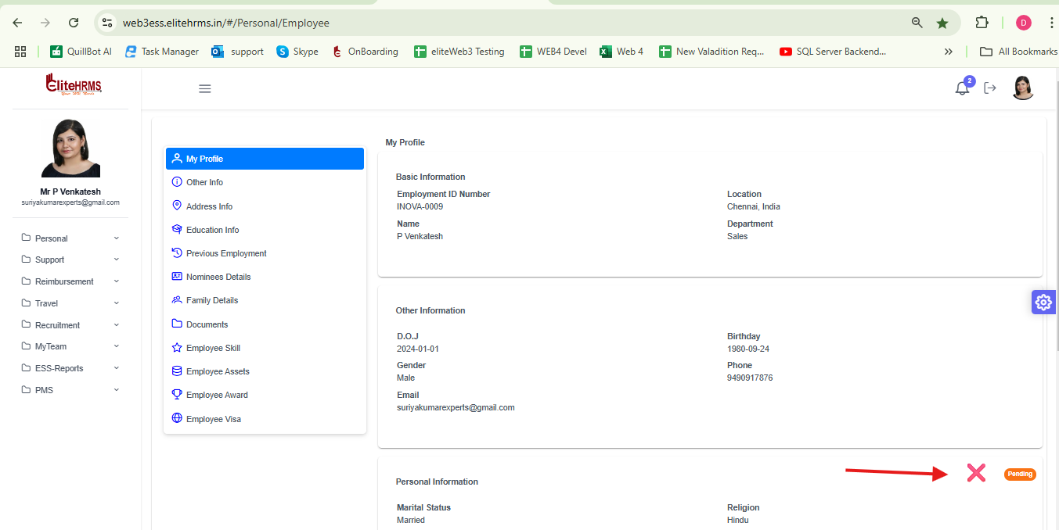
2. My Profile Address Info

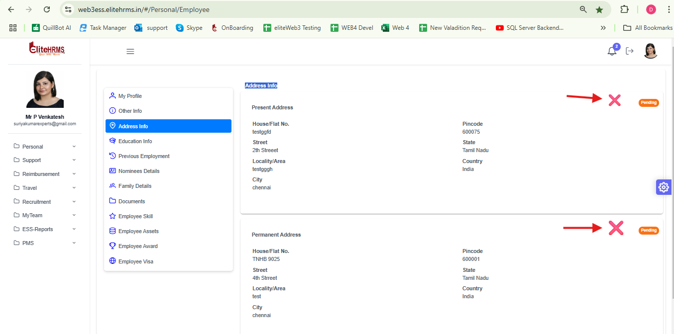

3. My profile Education

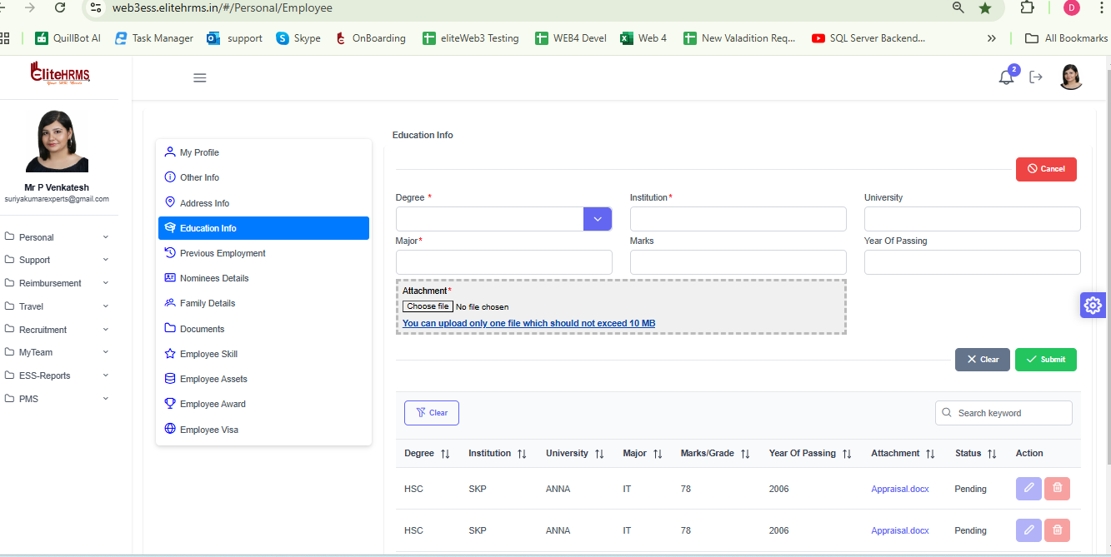

Minatory message needed for the attached file

4. My Profile - Previous Employment

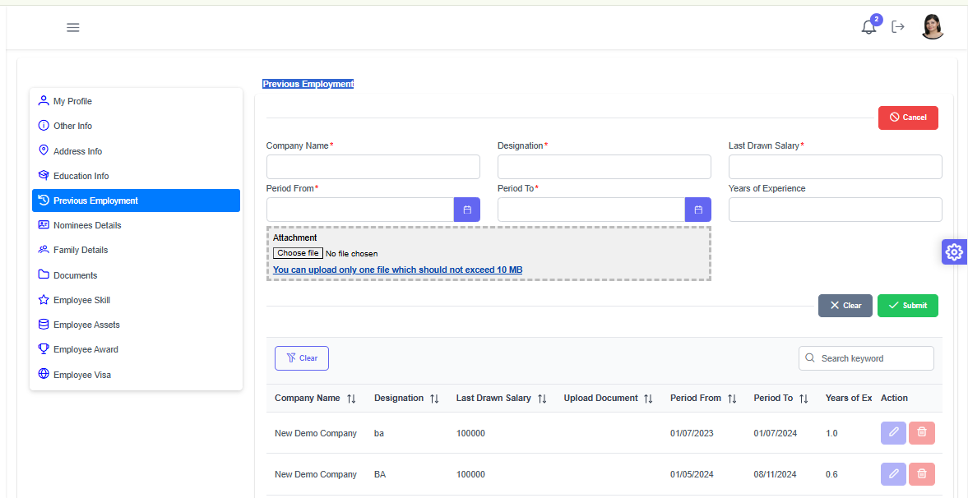

Minatory message needed for the attached file

5. My Profile Nominees Details

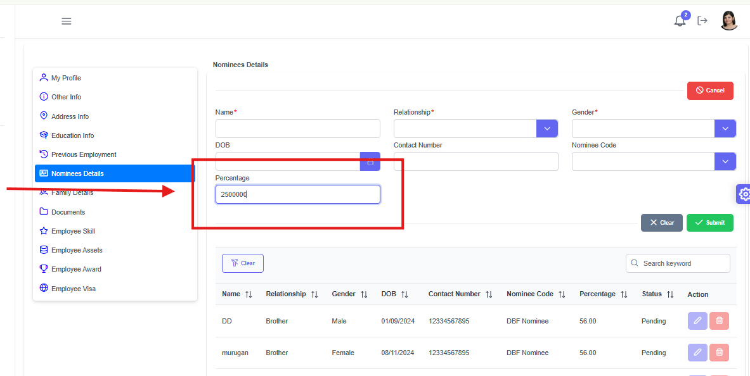

Add Validation for Percentage text box

6. My Profile - Family Details

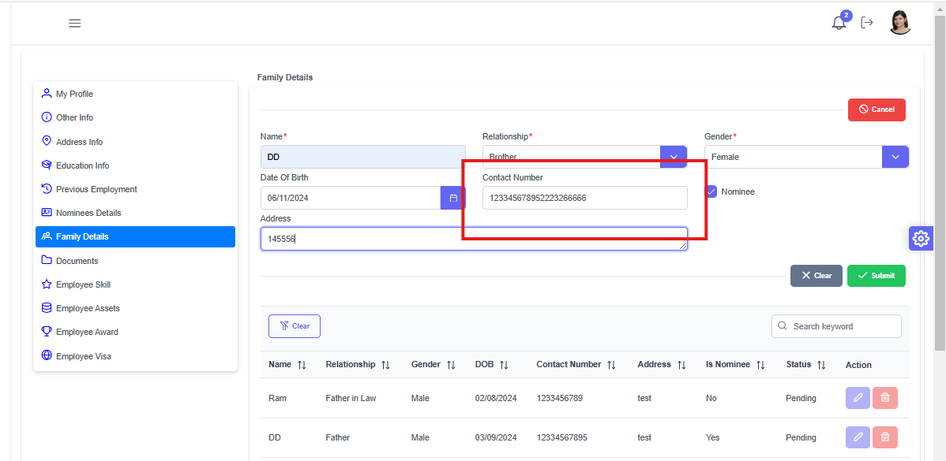

Add Contact Number to validation required

8. My Profile Documents
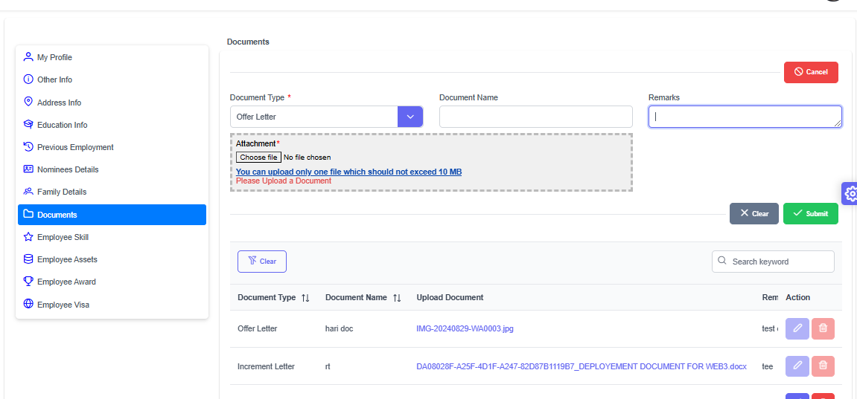

Minatory message needed for the attached file

9. My Profile Employee Skill - Working fine

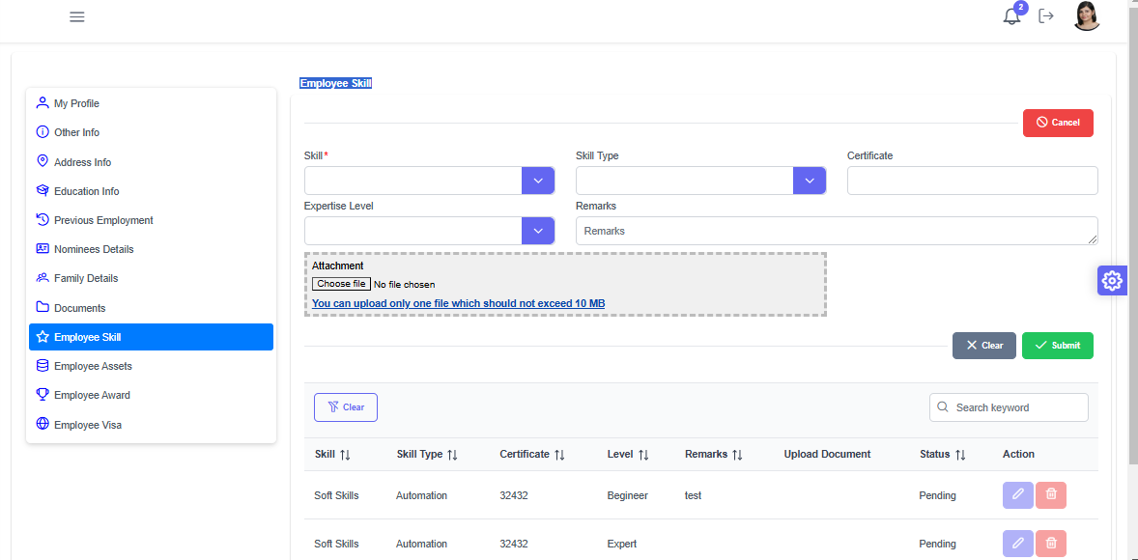

10. MY Profile - Employee Assets Request

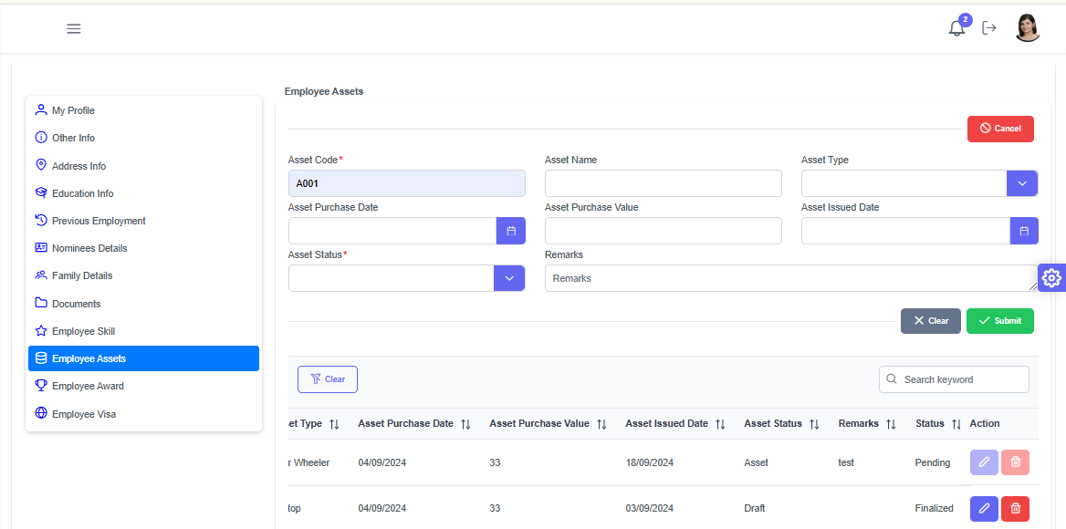

Asset code need for dropdown Required

11. My Profile - Employee Award - Working Fine

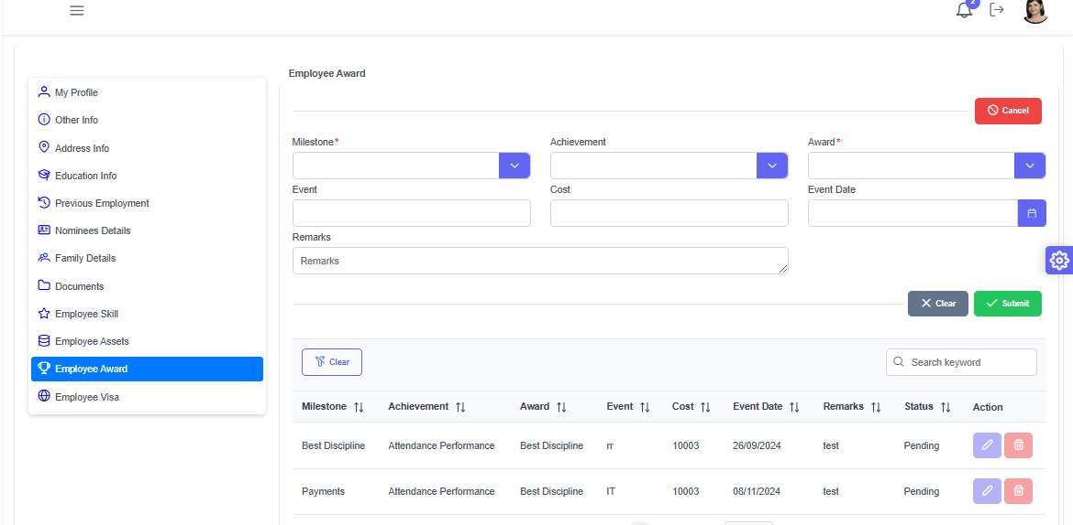

12. My Profile Employee Visa – Working fine

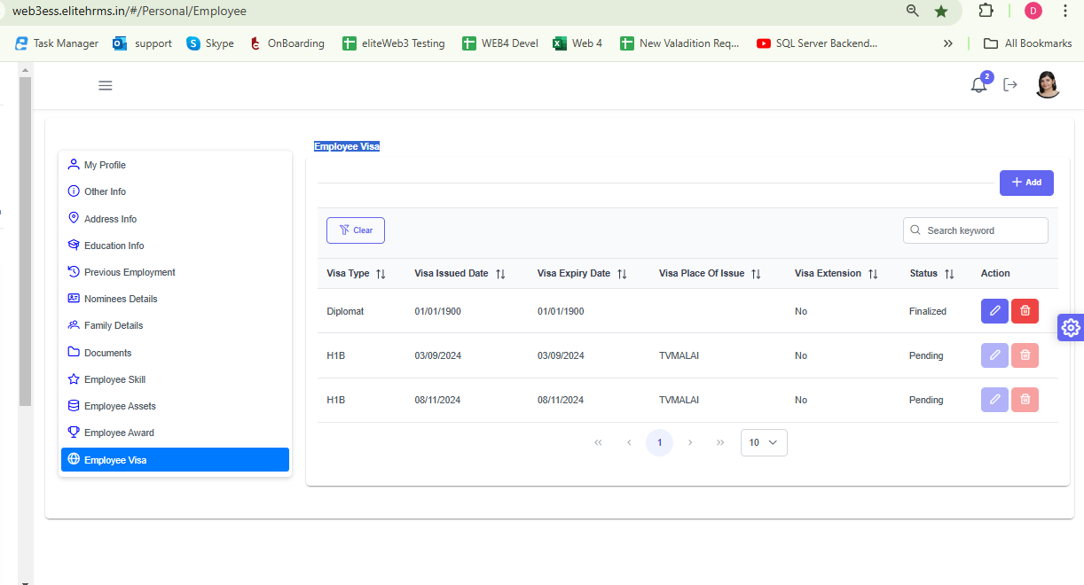

Personal MY Calendar

1. Leave Request

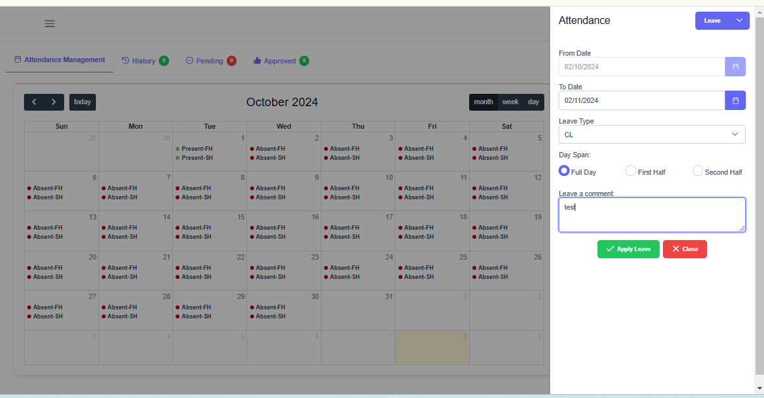

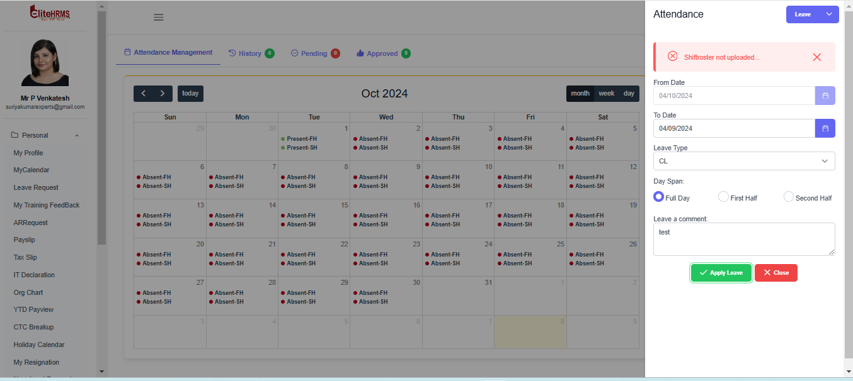

Shift Details Available but API to give Shift not Available

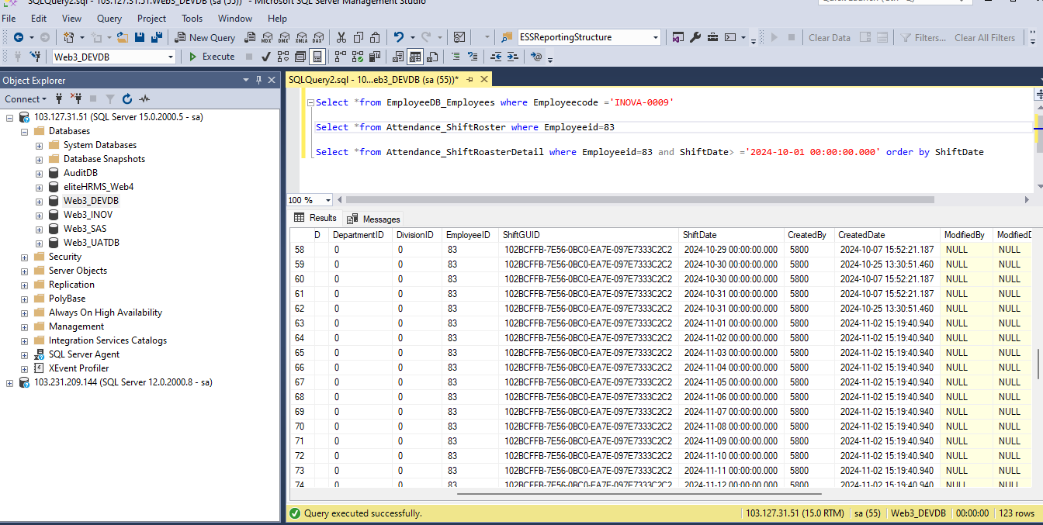

Approval Routing Mapped in Web3
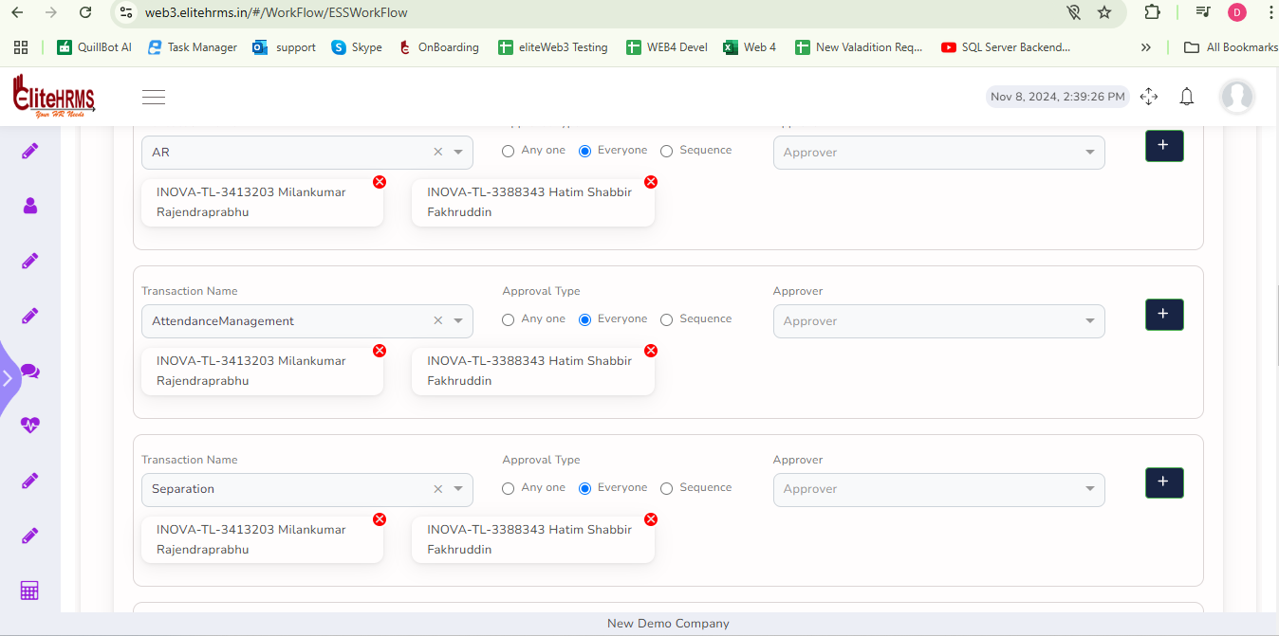

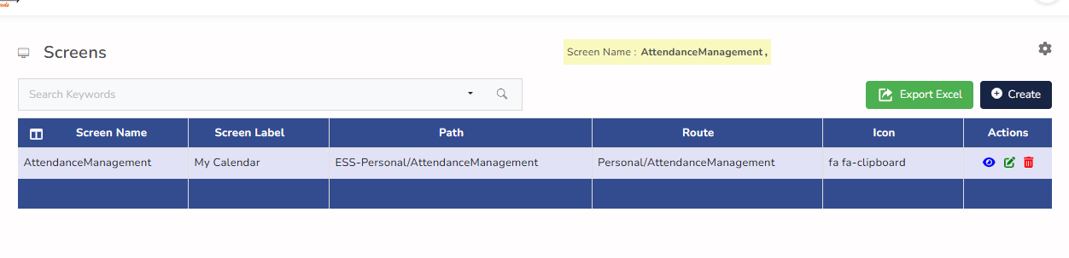
https://web3essapi.elitehrms.in/api/Personal/PostLeaveRequest
{"LeaveGUID":"43ed13ea-b376-79cb-4779-a6705f5783b4","Fromdate":"2024-10-02","Todate":"2024-10-02","LeavetypeID":"2","DaySpanID":"3","Leavestatus":"Draft","Remarks":"test","ScreenID":1685}
{
"Response": {
"_status": "Failed",
"_code": "333",
"_Source": "PostLeaveRequest",
"_Description": "Shiftroster not uploaded...",
"_Details": "",
"_TransID": null,
"_Timestamp": "20241108144159"
},
"LeaveDetail": [],
"LeaveBalance": []
}

- On duty

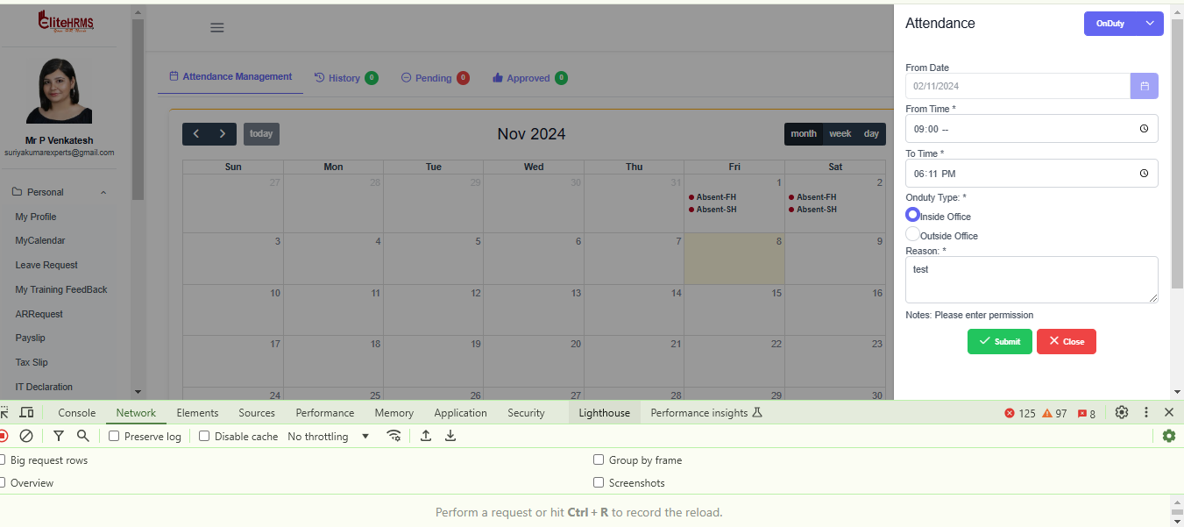

https://web3essapi.elitehrms.in/api/Personal/PostHourlyOnduty

{
"DateOfOnduty": null,
"FromTime": "09:30",
"ToTime": "18:30",
"Hours": null,
"Ondutytype": null,
"Status": null,
"Remarks": "test",
"lateOption": null,
"ScreenID": 1685,
"Fromdate": "2024-10-16",
"OndutyType": "Inside Office"
}

{
"Response": {
"_status": "Success",
"_code": "111",
"_Source": "PostHourlyOnduty",
"_Description": "Inserted Successfully...",
"_Details": "Workflow screen not added",
"_TransID": null,
"_Timestamp": "20241108145149"
},
"HourlyOndutyGUID": "DF7A2E4E-0F1D-4E9C-B56D-CC0A25D47671 ",
"DateOfOnduty": null,
"FromTime": null,
"ToTime": null,
"Hours": null,
"Status": null,
"Remarks": null,
"ScreenID": 0
}

- Miss Punch

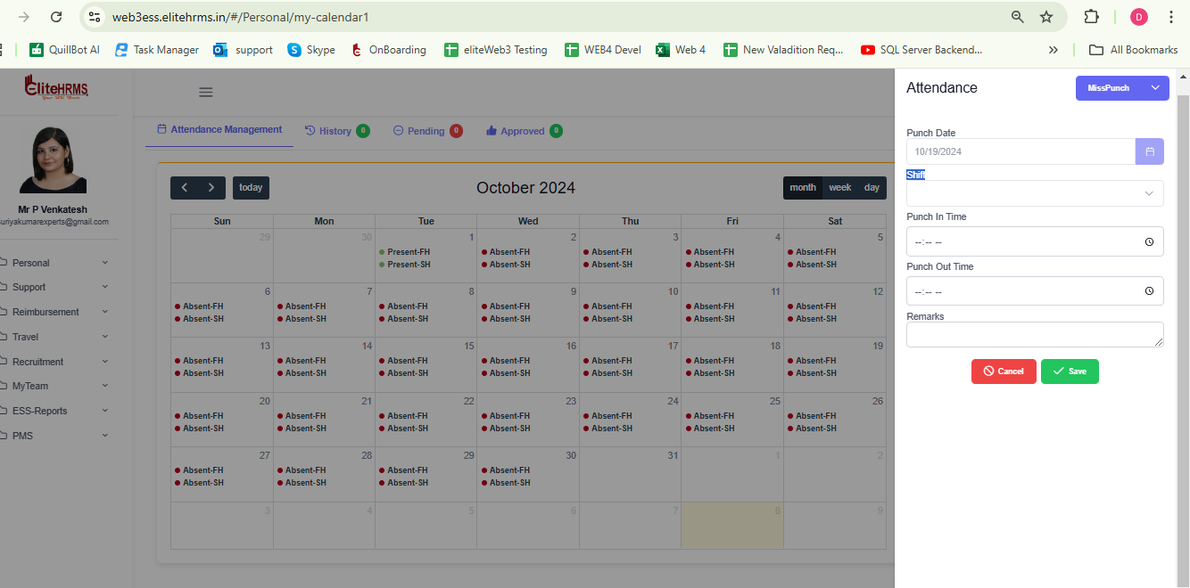

https://web3essapi.elitehrms.in/api/Personal/PostManualPunch

{"ManualPunch":[{"PunchDate":"2024-10-15","ShiftGUID":"aba13d91-260a-3ece-c480-43b0c5c9acd6","PunchInTime":"09:30:00","PunchOutTime":"18:30:00","Remarks":"rtr","ScreenID":1685}]}

{
"Response": {
"_status": "Success",
"_code": "111",
"_Source": "PostManualPunch",
"_Description": "Mis Punch Inserted Successfully...",
"_Details": "Workflow screen not added",
"_TransID": null,
"_Timestamp": "20241108144916"
},
"ManualPunch": []
}

- Shift Details is not Load
- Workflow Not Add to show the Error
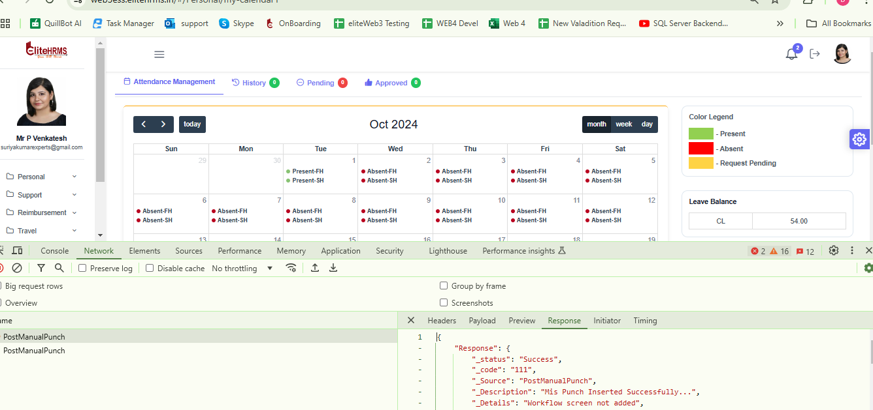
Workflow Is mapped

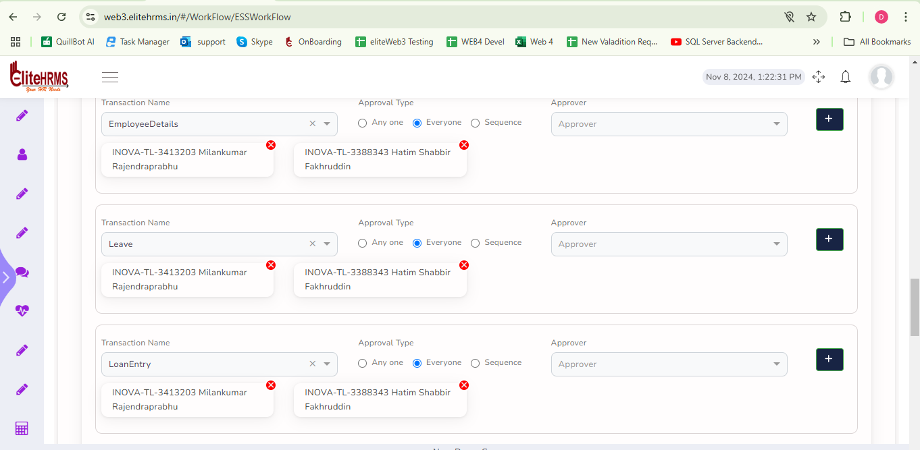

- Permission is not Show the My Calendar option

- Hourly On duty Is not Show

Personal Leave Request

To display the error, include the leave request for the feature date.

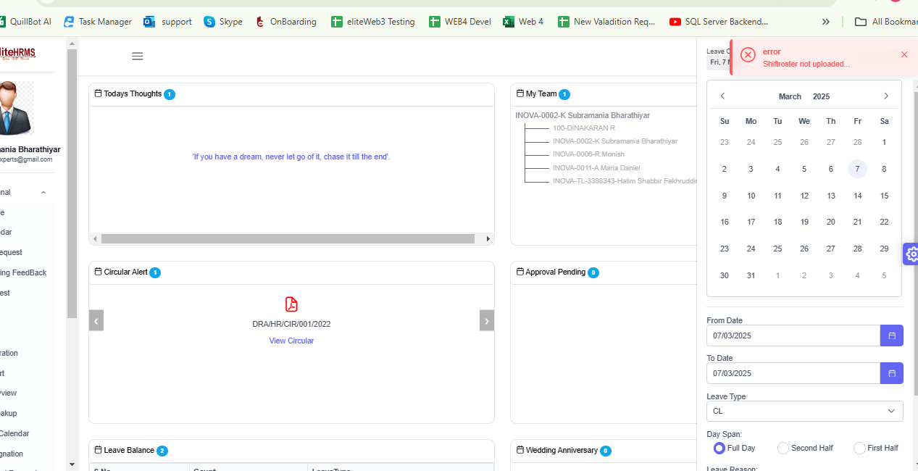

Edit

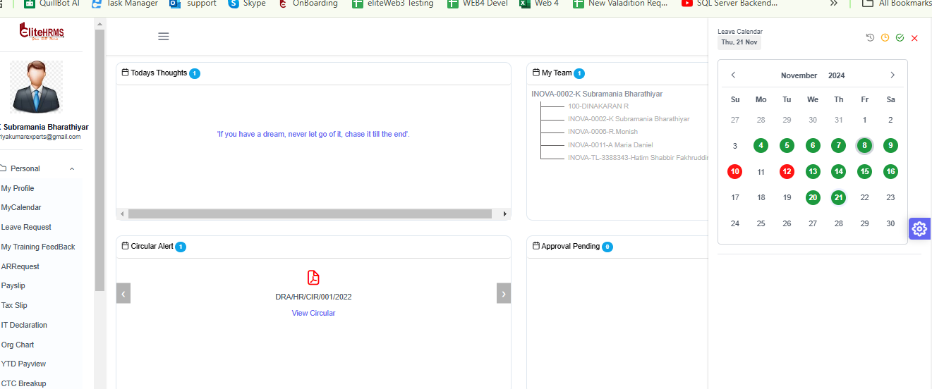
When editing the leave request date data, the leave type, date, and number of days are not bonded.
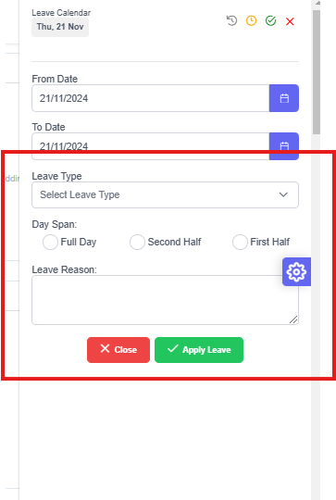

When you modify the leave type, days span, and remarks, the request will be updated to display an error message.

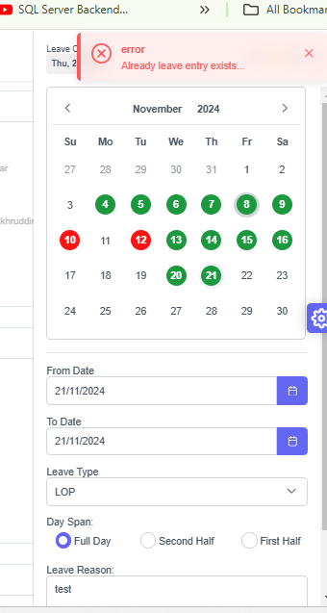

Case : Duration Leave Request
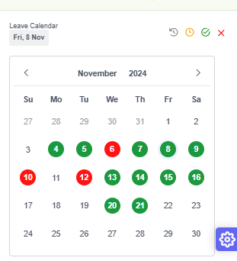

While submitting a leave request for November 21, 2024, to November 23, 2024, the system had previously accepted the request for November 21, 2024.

https://web3essapi.elitehrms.in/api/Personal/PostLeaveRequest

{
"LeaveGUID": "166bc821-e80b-079d-c40d-522f4a802719",
"Fromdate": "2024-11-21",
"Todate": "2024-11-28",
"LeavetypeID": "5",
"DaySpanID": "6124",
"Leavestatus": "Draft",
"Remarks": "test",
"ScreenID": 243
}

{
"Response": {
"_status": "Success",
"_code": "111",
"_Source": "PostLeaveRequest",
"_Description": "Your leave has been applied Successfully...",
"_Details": "",
"_TransID": null,
"_Timestamp": "20241108185822"
},
"LeaveDetail": [],
"LeaveBalance": []
}
But is not Show Colour
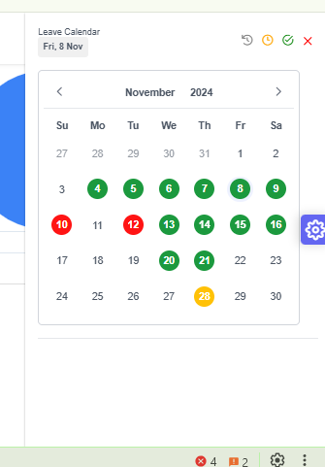
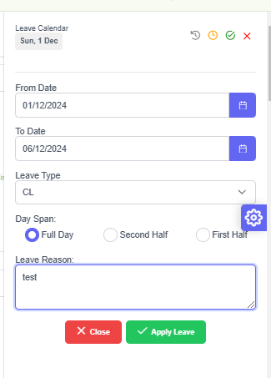

Duration is used to apply for leave, although the system only displays the colour on one day.

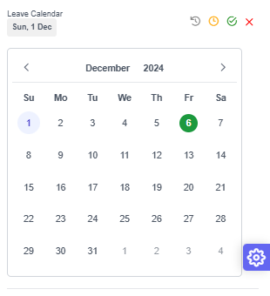

Personal - My Training Feedback Form

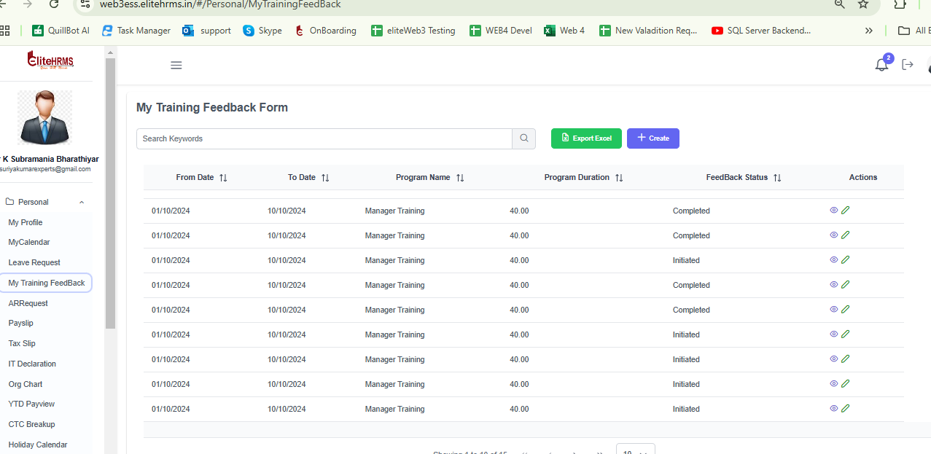

As per Role rights create Mode is disable but to show the Create Button

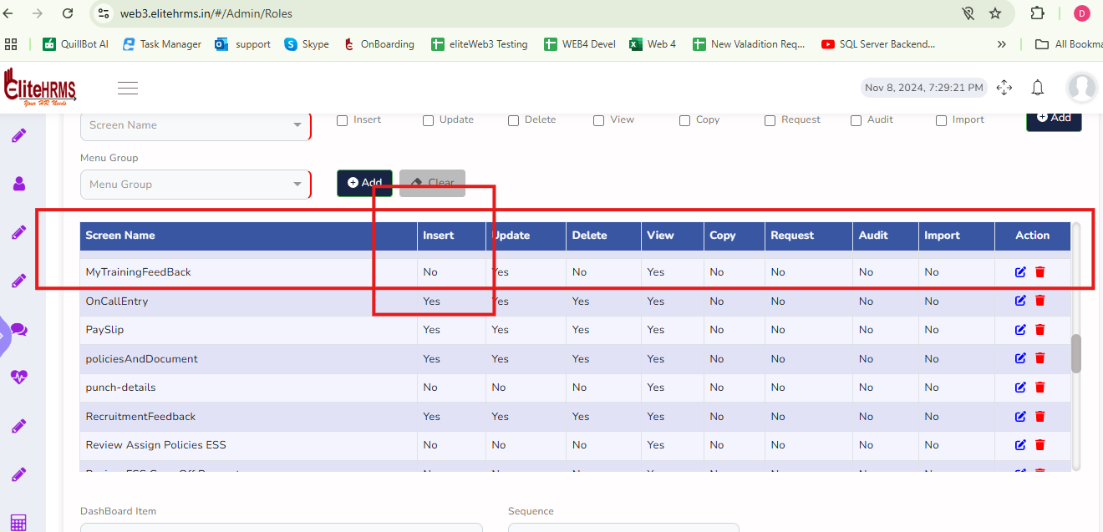

AR Request -On duty -Working fine

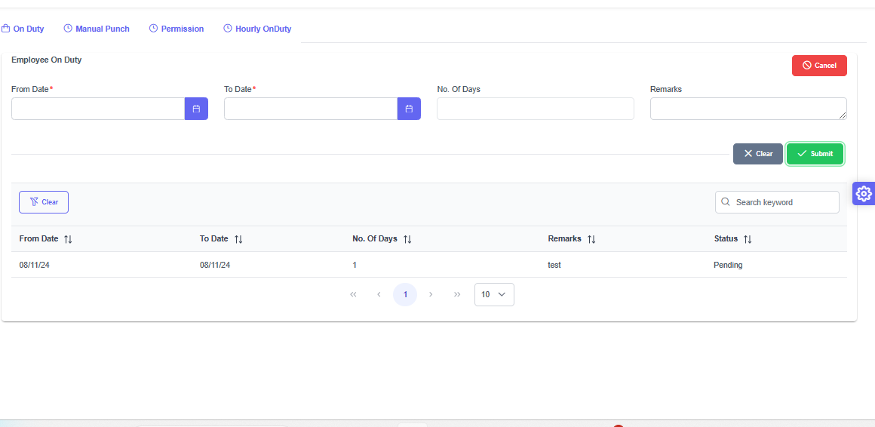

AR Request - Manual Punch - working

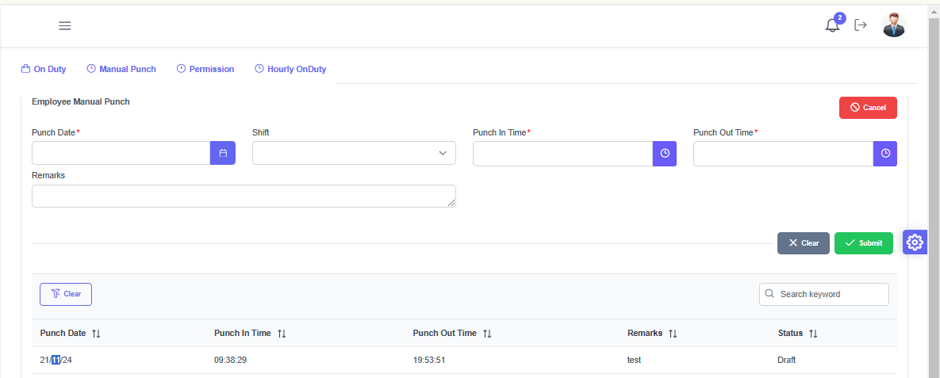
1. When choosing Punch Date to display current shift information
2. It is necessary to validate punch-in and punch-out times.
3. When choosing Punch Date, if Punch information is already provided, it displays the In and Out times.

AR request - Permission

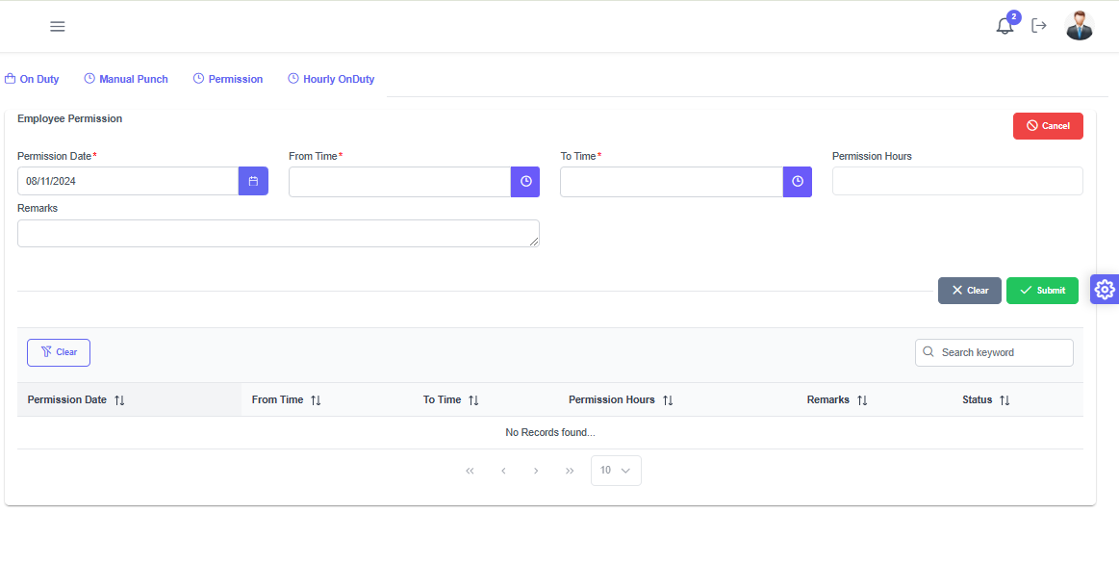
1. When choosing the Permission Date in Past Date, the Punch In and Punch Out Times are displayed.
2. Selecting the date of permission Punch details do not need to include the current date or feature date.
3. The rule that grants permission is not functioning

AR Request Hourly On duty

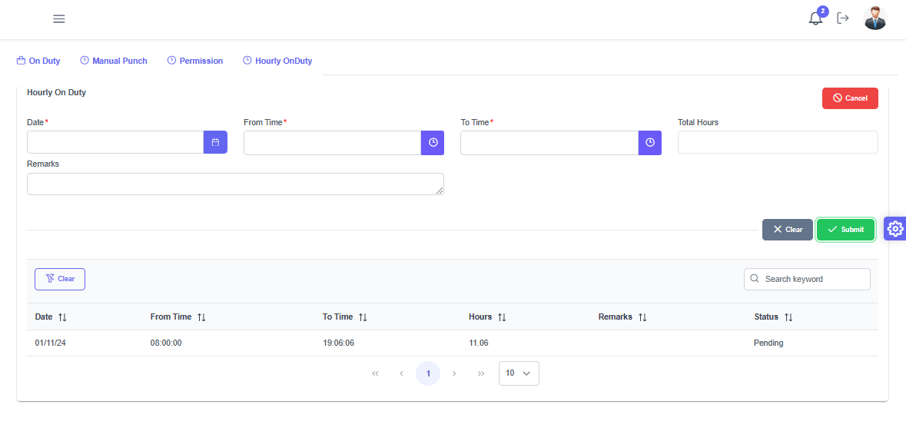

1. When choosing the Hourly On duty Date in Past Date, the Punch In and Punch Out Times are displayed.
2. Selecting the date of Hourly On duty Date Punch details do not need to include the current date or feature date.

AR request Payslip - Working Fine

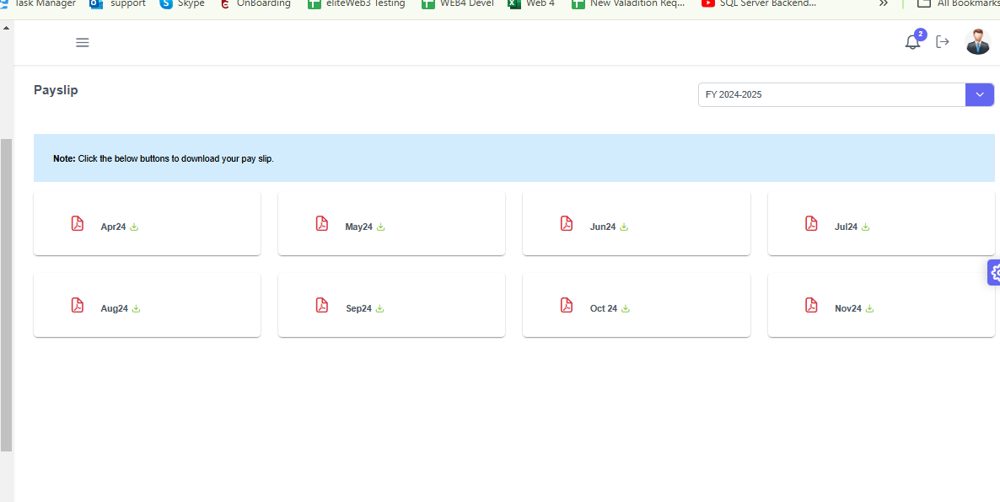

Payslip Downloaded Option working But View Option required

08/11/2024

- Infra Request Date and Id Removed
- Request type Select automatically to load infraDeparmnet
- Policy Document view option

Bulk Approval is not working

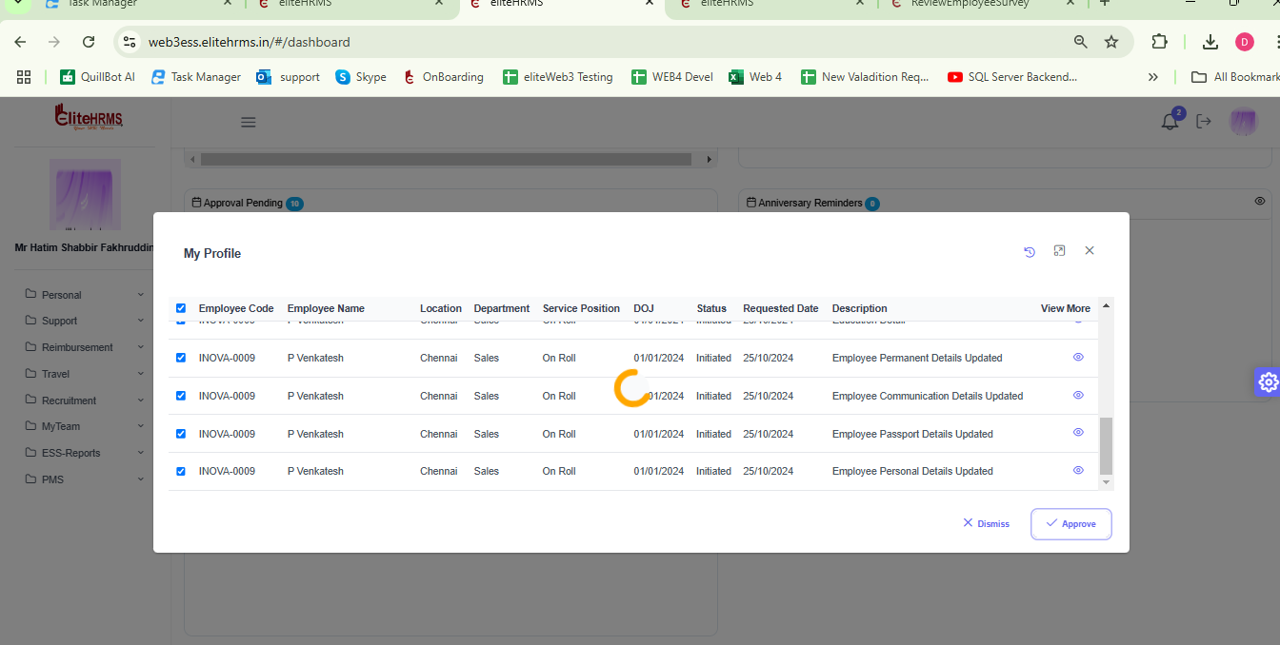

2. Bulk Reject is not Working

